ISSS608 Visual Analytics and Applications
Timed Individual Assessment

DataVis Makeover is the process of redesigning existing data visualisation or dashboards to improve their clarity, effectiveness, and storytelling capacity. It focuses on applying best practices to make data easier to understand.

The Task
- Evaluate the data visualisation provided by identifying its strengths and weaknesses.
- Sketch a redesigned visualisation that improves the clarity, effectiveness, and storytelling of the original.
- Create the redesigned visualisation (DataVis Makeover) using Tableau Desktop.
- Describe the labour force participation trends and patterns reveal by the DataVis Makeover.

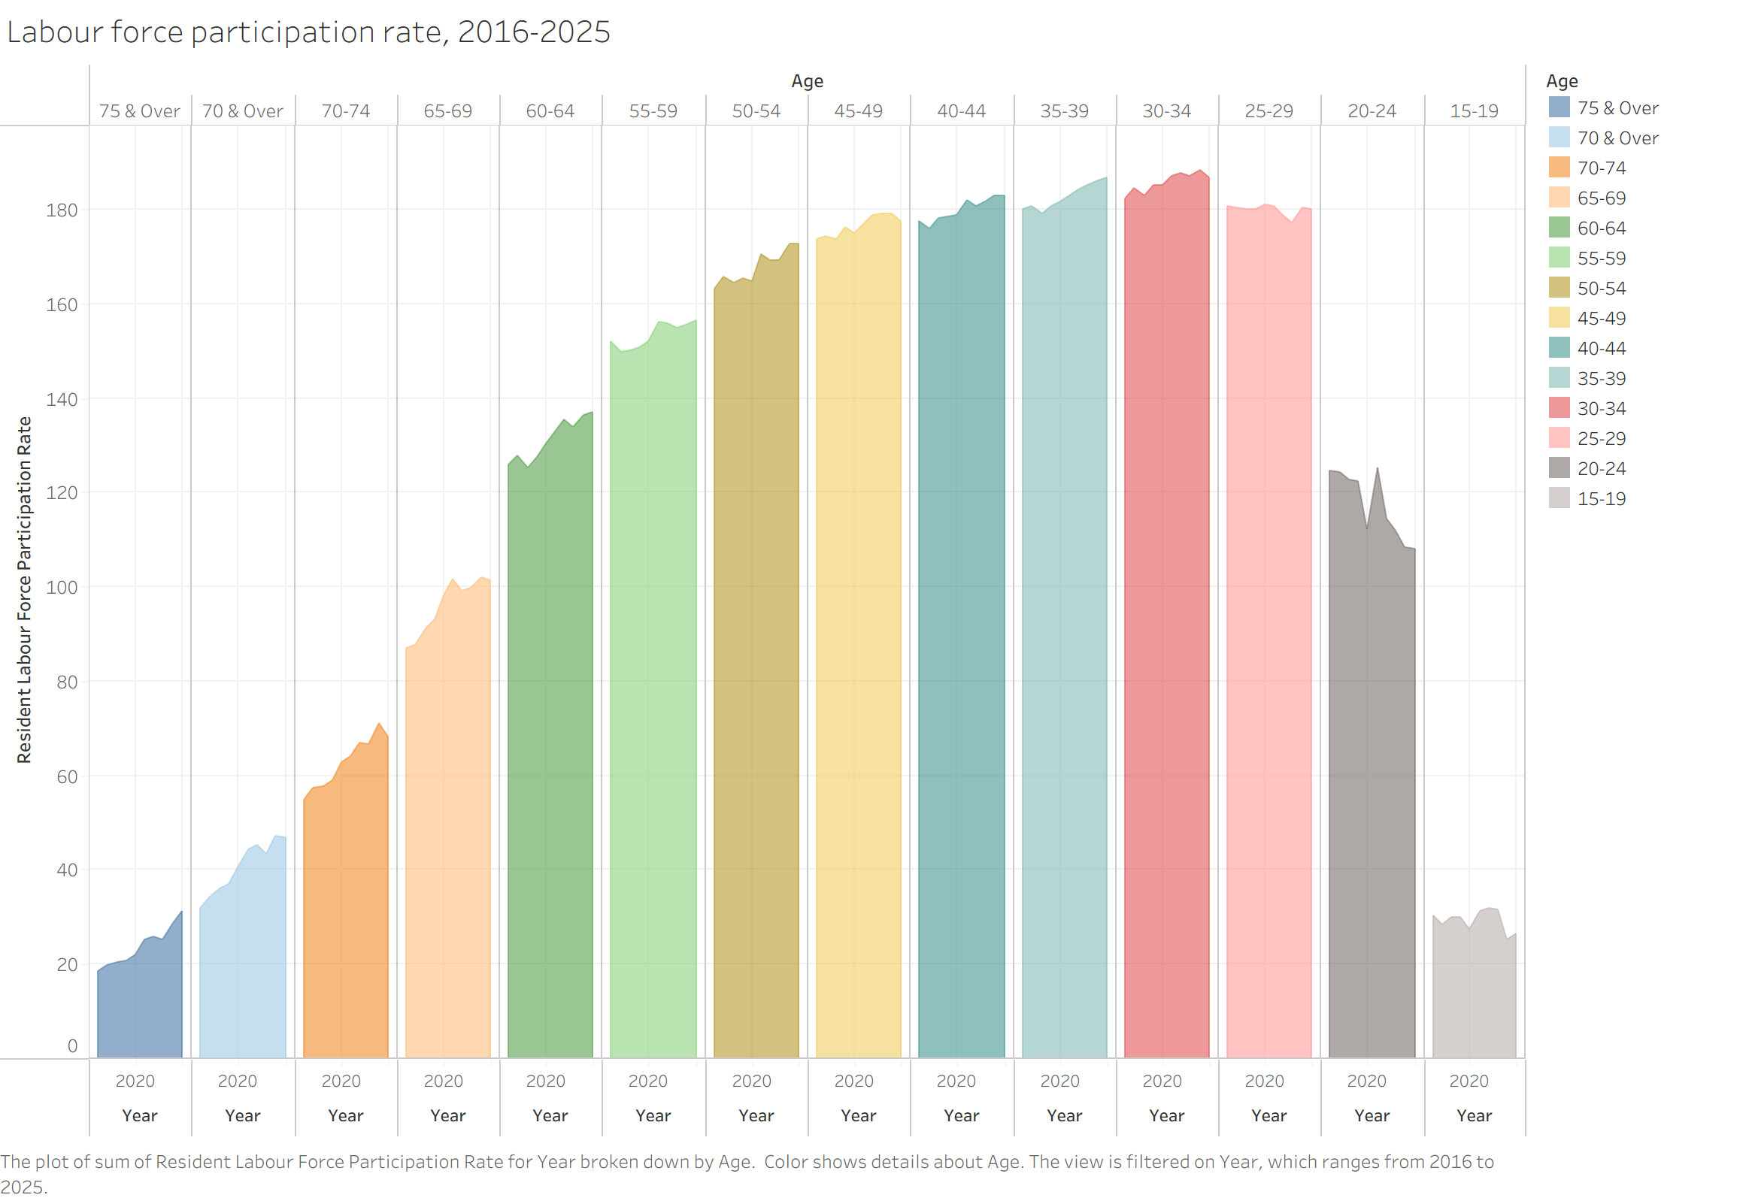

Submission Instructions
This is a timed individual assessment. You are required to complete the DataVis Makeover individually within 1 hour and 30 minutes during the class session.

- Write-up
You are required to submit a write-up in Microsoft Word format via eLearn. The write-up should include, but is not limited to, the following:
- At least three strengths of the original data visualisation.
- At least two weaknesses related to clarity and two related to aesthetic of the original data visualisation.
- A sketch of the redesigned visualisation, together with a brief explanation of how the redesign addresses the weaknesses identified in the original visualisation.
- At least five labour force participation trends and patterns revealed by the DataVis Makeover.

- Tableau Visualisation
Publish your DataVis Makeover on Tableau Public and submit the link via eLearn.

Answer.
Strength of the chart
- Showing which age group have relatively higher/lower participation ratio
In this chart it allows us to read from the age 25 to 64 have relatively higher participation ratio.
- The color of group is clear to distinguish between different ages.
- The chart has provided the explanation below the chart, allow us to understand the information background of the chart.
Weakness of the chart
Clarity
- Hard to compare different age group participation rate in each year
The chart right now is like one age group for one column, if the user wants to compare the participation rate for each age group in a specific year, it is hard to show the same year data of each group simultaneously. (I think even hover to the data can only show one age group with one year data.)
- Group “75 & Over” and “70 & Over” and “70-74” have duplicate part
The group division is unclear. There are three groups that seem to have duplicate age range. For example, “70-74” is part of “70 & Over”, “70 & Over” is also part of “75 & Over”, It should be only group “70-74” and “75 & Over”.
- It is weird to show “the sum of” partition ratio
User is expected the partition ratio will be 100% in max. Right now, the sum of partition ratio is showing, so the Y-axis will be over 100%. What’s more, the ratio should add the symbol of “%”, in the original data may bring misunderstanding of Y-axis definition (Some may think is it represent count or other?)
Aesthetic
- Hard to view the trend of different age groups
Because of the view limitations of the screen, Year label of each group is squeezed, so we can only see the Y2020 label, however the chart is containing the record between 2016 to 2025. In such situations it is also hard for user to read for a specific age group which year is risen or which year is drop.
- The colour is abundant but not useful
Right now, each group has different colour, it will be better to change the colour to Gradient to show the increasing/ decreasing age trend.
- Age is showing in descending order
For public’s reading habit, the minimum number will be the left of the chart, and the maximum number will be the right of it. In the original chart, the x axis is show in elder-younger, it will be better to switch to younger-elder.

Tableau Report
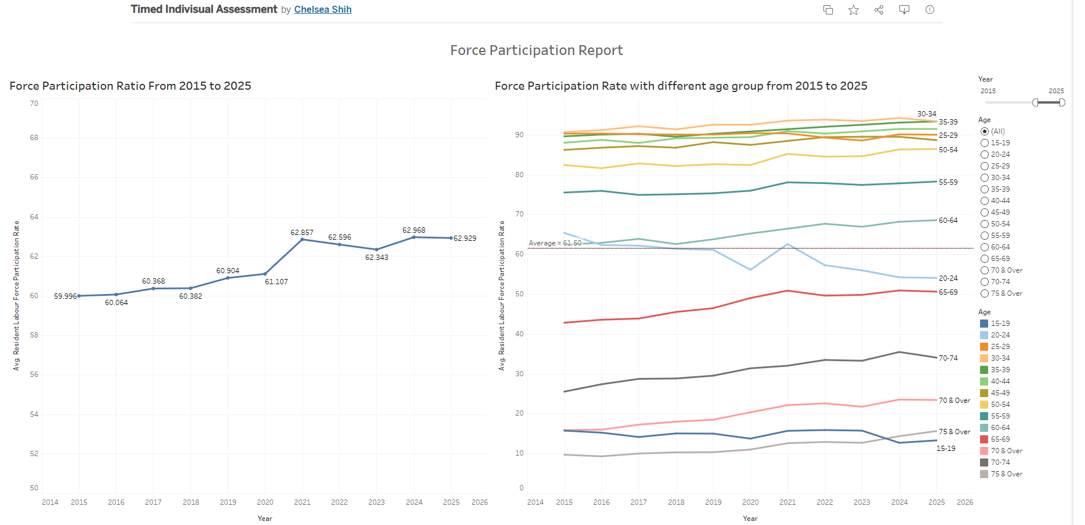
https://public.tableau.com/app/profile/chelsea.shih/viz/TimedIndivisualAssessment/Dashboard1?publish=yes
This graph allow to read the trend of participation rate over the year and finding out the trend of different age groups. User can filter the year to find the trend for specific time range base on their need.
In detail it also show the average of each year for each age group.
Trend and pattern
- Force participation rate is showing the increasing trend after 2020
After 2020, participation rate has an significant rise, increase for more than 1%, by reading the graph over the right side, it seems both 20-24 and 65-69 have relatively stronger risen strength.
- Age group from 25-64 have relatively higher participation
From age 25-64 have higher participation rate, which are always higher than average in the data. The chart shows that 25-59 groups always with higher and stable participation rate, 60-64 have greater growth on participation ratio.
- Younger (20-24) participation rate is getting lower
Before 2018, 20-24’s participation ratio is higher than the average of the data, but in 2018 it’s below to the average line, although in 2021 have risen, but in the whole trend is getting lower.
- Age from 60 to74 have relatively stronger risen trend
The participation ratio is getting higher over the year; it affects the scenario of the retirement age is getting older. Especially, Group 65-69 and 70-74 risen strongly, it shows that more people retire later instead of at their 60-65.
- Force participation ratio will become stable
Because of the risen of elderly participation rate and the fallen of younger, the trend of participation rate is getting stable.

Assessment Rubic
Criteria | Excellent | Good | Satisfactory | Needs Improvement | Weights
Critique of Original Data Visualisation | Provides clear, insightful, and well-structured critique. Strengths and weaknesses are accurately identified and well justified using data visualisation principles. | Provides a logical critique with appropriate identification of strengths and weaknesses, with some supporting explanation. | Identifies some strengths and weaknesses but explanations are limited or partially unclear. | Limited or unclear critique. Strengths and weaknesses are poorly identified or unsupported. | 20%
Redesign Proposal (Sketch & Explanation) | Redesign sketch is clear and well thought out. Explanation clearly shows how the new design addresses the weaknesses and improves clarity and storytelling. | Redesign is reasonable and addresses most weaknesses. Explanation is generally clear. | Redesign addresses some weaknesses but explanation lacks clarity or completeness. | Redesign is unclear or does not meaningfully address the weaknesses identified. | 20%
Implementation Using Tableau Desktop | Tableau visualisation is well designed, clear, and visually effective. Appropriate chart types, layout, labels, and formatting are used. | Tableau visualisation is generally clear with appropriate chart type and layout, with minor issues. | Tableau visualisation is functional but contains several clarity or formatting issues. | Tableau visualisation is incomplete, difficult to interpret, or poorly implemented. | 25%
Visual Storytelling and Insight Communication | Provides clear and insightful interpretation of trends and patterns revealed by the DataVis Makeover. Insights are well articulated and supported by the visualisation. | Describes key trends and patterns with reasonable clarity, though explanation may lack depth. | Identifies some trends or patterns but explanation is limited or partially unclear. | Little or no meaningful interpretation of the trends or patterns shown in the visualisation. | 20%
Bonus: Creativity & Storytelling | Demonstrates exceptional creativity, strong visual hierarchy, and compelling storytelling. | Shows good creativity and visual improvement over the original design. | Shows limited creativity but improves some aspects of the original visualisation. | Little or no improvement in creativity or storytelling. | 15%

